29.42: a) Just under 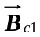(threshold of superconducting phase), the magnetic field in the material must be zero, and 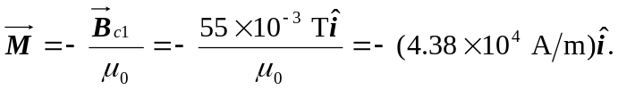
b) Just over 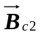 (threshold of normal phase), there is zero magnetization, and 